Progress Report
Dong Wuzheng A0352274E
Yang Guanxi A0356000X
Gao Hongye A0351080R

1 Introduction
This project implements a distributed attention kernel for long sequences and measures its correctness and runtime on CPU and NVIDIA GPUs. Standard attention computes every query against every key, so for fixed feature dimensions, the arithmetic complexity of dense attention grows quadratically with sequence length $N$.. Ring Attention distributes query and key/value blocks across GPUs: each GPU keeps its query block, while key/value blocks circulate between ranks. This lets the GPUs share the attention work without gathering the complete key/value sequence on every device.

2 Methodology

2.1 Attention Formulation and Notation
For queries$Q$, keys$K$, values$V$, and key dimension$d_{k}$, the reference operation is:
$$\begin{aligned}S&=\frac{QK^{⊤}}{\sqrt{d_{k}}} \\ O&=\text{softmax}\left(S+M\right)V\end{aligned}$$
In the implementation and experiment tables, $d$ denotes the query and key dimension, corresponding to $d_{k}$ in the equation, and $d_{v}$ denotes the value dimension. Thus, $Q,K∈R^{N×d}$, $V∈R^{N×d_{v}}$, and $O∈R^{N×d_{v}}$. For clarity, d is the feature dimension of each query and key vector, and d_v is the feature dimension of each value vector. Thus Q,K ∈ R^(N×d), V ∈ R^(N×d_v), and O ∈ R^(N×d_v).
Here M is zero for allowed positions and −∞ for masked positions. In causal attention, a query at position i cannot use a key at a later position j> i.

2.2 Ring Attention and Blocking
Ring Attention partitions the query rows across GPU ranks. Each rank keeps its assigned query block and processes key/value blocks that circulate between ranks. The query block is divided into tiles of $B_{q}$ rows, while the key and value blocks are divided into tiles of$B_{k}$ rows. For each query tile, a rank computes attention against the key/value tiles as they arrive around the ring.
Blocking is applied to two loops. The query-row loop processes b_q rows together; the key/value loop processes b_k positions per tile as the blocks circulate between ranks. Each arriving key/value tile updates the running softmax state for the retained query block, avoiding construction of the full N×N score matrix.
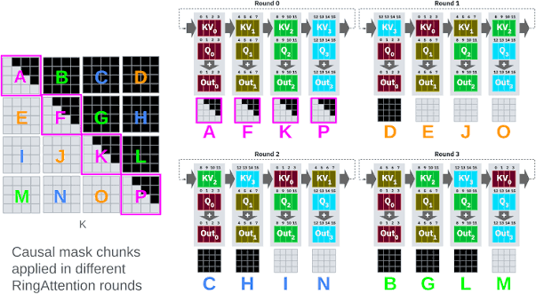
Figure 1. Each rank retains its query block and processes key/value tiles circulated around the GPU ring.
For each query row, the implementation maintains a running maximum $m$, a softmax denominator$l$, and a weighted value sum$u$. For a new score tile $s$, it updates these quantities as follows:
$$m'=\max\left(m,\max_{j}{s_{j}}\right)$$
$$l'=e^{m-m'}l+\sum_{j}{e^{s_{j}-m'}}, \\ u'=e^{m-m'}u+\sum_{j}{e^{s_{j}-m'}}v_{j}.$$
After all key/value tiles have been processed, the output row is $u/l$. This online update avoids storing the full$N×N$ attention-score matrix; intermediate scores are processed tile by tile. With fixed feature dimensions, the attention computation still grows quadratically with $N$.

3 Experiment
We evaluated five execution configurations: serial CPU, OpenMP CPU, local single-GPU CUDA on an NVIDIA RTX 4090, single-GPU CUDA on a Vanda A40, and two-node MPI+CUDA on two Vanda A40 GPUs. Performance measurements used$d=d_{v}=64$ and five repetitions unless otherwise stated. Small correctness tests used $N=257$, $d=31$, and $d_{v}=19$.

3.1 Serial CPU (FP64)
The serial CPU implementation used FP64 arithmetic and served as the CPU reference. Performance was measured at sequence lengths$N=512$, 1024, 2048, and 4096. Table 1 reports the measured runtimes.
Table 1. Serial CPU FP64 runtimes with$d=d_{v}=64$.
Sequence length $N$ | Median runtime
512 | 17.515 ms
1024 | 70.418 ms
2048 | 263.479 ms
4096 | 913.966 ms

3.2 OpenMP CPU (FP64)
The OpenMP CPU implementation used FP64 arithmetic. At $N=4096$, with $d=d_{v}=64$, we measured runtimes using 1, 2, 4, and 8 threads. Table 2 reports the measured runtimes.
Table 2. OpenMP CPU runtimes at $N=4096$,$d=d_{v}=64$.
CPU threads | Median runtime
1 | 914.491 ms
2 | 450.942 ms
4 | 236.177 ms
8 | 142.854 ms

3.3 Loval single GPU CUDA (RTX4090)
The local CUDA implementation was run on a single NVIDIA GeForce RTX 4090. The tests covered full and causal attention at $N=257$, followed by full-attention runs at $N=1024$ and $N=4096$. All four tests were checked against the FP64 CPU reference and passed validation.
Table 3. Local RTX 4090 CUDA validation and runtime results.
Test | Runtime | Validation
$N=257$, full attention | 0.609 ms | PASS
$N=257$, causal attention | 0.589 ms | PASS
$N=1024$, full attention, 5 repetitions | 0.718 ms | PASS
$N=4096$, full attention, 5 repetitions | 8.044 ms | PASS
The local NVIDIA GeForce RTX 4090 results in Table 3 include N=257 full and causal validation runs (0.609 ms and 0.589 ms), a five-repeat full-attention run at N=1024 (0.718 ms), and a five-repeat full-attention run at N=4096 (8.044 ms). Terminal evidence is shown in Appendix 1. These are local RTX 4090 results, not Vanda measurements.
The terminal captures which show the local GPU and the recorded CUDA validation and benchmark outputs are attached in Appendix 1.

3.4 Vanda Single GPU CUDA (A40, FP32)
The single-GPU CUDA implementation was run on one Vanda A40 GPU using FP32 arithmetic. The Vanda environment used CUDA Toolkit 12.4. Performance was measured at $N=512$, 1024, 2048, and 4096, with $d=d_{v}=64$.
Table 4. Vanda single-GPU A40 FP32 runtimes with $d=d_{v}=64$.
Sequence length $N$ | Median runtime
512 | 0.248 ms
1024 | 0.648 ms
2048 | 2.345 ms
4096 | 8.845 ms

3.5 Vanda Two-Node MPI+CUDA (2 × A40, FP32)
The distributed CUDA implementation was run on two Vanda nodes, with one A40 GPU per node. It used FP32 arithmetic, CUDA Toolkit 12.4, Open MPI 4.1.8, and host-staged MPI communication.
The first two-node attempt, Job 1475534, received two A40 nodes but stopped before GPU computation because Open MPI placed both ranks on the first node. We changed the launch mapping to place one rank on each node. The subsequent smoke test and full benchmark confirmed distinct rank hosts and completed successfully.
The reported two-node MPI+CUDA runtime was 5.115 ms at $N=4096$ and 18.908 ms at $N=8192$. Full and causal correctness tests at $N=257$, $d=31$, and $d_{v}=19$ both passed.
Table 5. Two-node Vanda correctness results against the FP64 CPU reference.
Attention mode | Input | Maximum absolute error | Relative L2 error | Result
Full | $$N=257, d=31, d_{v}=19$$ | 2.5164e-08 | 1.2781e-07 | PASS
Causal | $$N=257, d=31, d_{v}=19$$ | 7.4686e-08 | 8.9793e-08 | PASS
For each output element y_i and FP64 reference value y_ref,i, maximum absolute error is max_i |y_i − y_ref,i|, and relative L2 error is ||y − y_ref||_2 / ||y_ref||_2. Full and causal attention are checked separately against the reference.

4 Result

4.1 Performance Comparison
Table 6 compares the serial CPU FP64 and Vanda single-GPU FP32 runtimes across sequence lengths. The CPU and GPU implementations use different numerical precision, so these measurements provide project baselines rather than a controlled comparison at identical precision.
Table 6. Serial CPU and Vanda single-GPU performance with $d=d_{v}=64$. Added Vanda CPU FP32 and A40 FP64 measurements are shown in brown.
$$N$$ | Serial CPU FP64 | Vanda A40, one-GPU FP32 | Serial CPU FP32 | Vanda A40, single-GPU FP64
512 | 17.515 ms | 0.248 ms | 14.486 ms | 0.568 ms
1024 | 70.418 ms | 0.648 ms | 56.536 ms | 1.869 ms
2048 | 263.479 ms | 2.345 ms | 155.295 ms | 7.187 ms
4096 | 913.966 ms | 8.845 ms | 678.629 ms | 28.348 ms
8192 | 4146.970 ms | 33.379 ms | 3041.366 ms | 113.447 ms
16384 | 31973.437 ms | 137.158 ms | 12384.594 ms | 452.009 ms
32768 | — | 547.723 ms | 78013.515 ms | —
65536 | — | 2197.395 ms | — | —
Added Vanda CPU FP32 and A40 FP64 timings are same-N measurements. CPU timings at N=8192 and above use three repetitions; the other added CPU/GPU timings use five repetitions. CPU/GPU timing ratios are system comparisons and should not be attributed to precision alone. For A40 FP32, original Table 6 values through N=4096 are retained from the earlier benchmark; values from N=8192 onward are follow-up results. Table 10 is a separately paired strong-scaling run, so its N=4096 single-A40 value (8.468848 ms) differs from Table 6 (8.845 ms).
At$N=4096$, the serial CPU took 913.966 ms, the eight-thread OpenMP implementation took 142.854 ms, the single Vanda A40 took 8.845 ms, and the two-node MPI+CUDA run took 5.115 ms. Figure 6 compares these recorded runtimes.
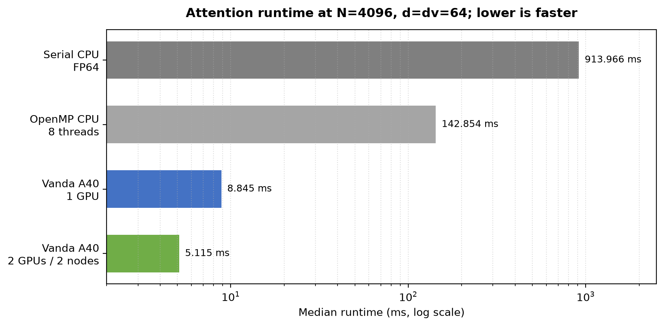
Figure 6. Runtime comparison at $N=4096$, $d=d_{v}=64$. Runtime is shown on a logarithmic horizontal axis.
The local RTX 4090 also passed the reported validation tests. At $N=257$, $d=31$, and $d_{v}=19$, its full-attention output had a maximum absolute error of 3.5195e-08 and a relative L2 error of 1.6572e-07 against the FP64 reference.

4.2 Scaling and Tile-Size Analysis
For fixed feature dimensions, dense attention requires approximately quadratic arithmetic work as $N$ increases. Table 7 reports the runtime ratio for each doubling of sequence length.
Table 7. Runtime growth when sequence length doubles, with $d=d_{v}=64$.
$$N$$ | Serial CPU FP64 | Vanda A40, one-GPU FP32 | Runtime ratio vs previous row, CPU / GPU
512 | 17.515 ms | 0.248 ms | —
1024 | 70.418 ms | 0.648 ms | 4.02× / 2.61×
2048 | 263.479 ms | 2.345 ms | 3.74× / 3.62×
4096 | 913.966 ms | 8.845 ms | 3.47× / 3.77×
For fixed d and d_v, dense attention requires O(N²(d+d_v)) arithmetic, which becomes O(N²) when feature dimensions are fixed. The repeated Vanda A40 FP32 sweep grew by 3.73×, 3.95×, 3.94×, 4.11×, 3.99×, and 4.01× for successive doublings from N=1024 to 65536. A40 FP64 grew by 4.00× from N=4096 to 8192 and 3.98× from N=8192 to 16384. Vanda CPU FP32 grew by 4.07× from N=8192 to 16384, then 6.30× from N=16384 to 32768; this deviation is reported without assigning an unmeasured cause.
The measurements broadly follow the expected quadratic trend. Doubling $N$ increased the CPU runtime by 3.47–4.02× and the single-GPU runtime by 2.61–3.77×.
For OpenMP, increasing the thread count from one to eight reduced runtime from 914.491 ms to 142.854 ms at $N=4096$. The measured reduction demonstrates that the CPU implementation benefits from parallel execution within the tested thread range.
The two-node experiment also tested different query and key/value tile sizes. Table 8 reports the measured runtimes.
Table 8. Two-node MPI+CUDA runtimes for different tile sizes.
$$N$$ | Query tile size $b_{q}$ | Key/value tile size $b_{k}$ | Median runtime
2048 | 64 | 128 | 4.011 ms
2048 | 64 | 256 | 2.493 ms
2048 | 128 | 128 | 2.288 ms
2048 | 128 | 256 | 1.469 ms
4096 | 64 | 128 | 15.308 ms
4096 | 64 | 256 | 9.361 ms
4096 | 128 | 128 | 8.169 ms
4096 | 128 | 256 | 5.124 ms
For N=4096, the number of query/key-value tile pairs is ceil(N/b_q)×ceil(N/b_k): 2048 pairs for 64×128 and 512 pairs for 128×256. The measured two-node median fell from 15.308 ms to 5.124 ms. Larger tiles reduce loop iterations and increase work per tile; possible data-reuse or launch-amortization benefits are plausible explanations, but the available runs do not isolate cache, occupancy, or launch effects.
Among the tested configurations, $b_{q}=128$ and $b_{k}=256$ produced the lowest runtime at both sequence lengths. Larger tiles can reduce the number of tile iterations and allow more work to be performed on each loaded block. The measurements establish the observed improvement; they do not independently identify the contribution of each hardware or communication effect.
In the separate full-versus-causal measurements at $b_{q}=128$, $b_{k}=256$, the full and causal medians were 5.226 ms and 5.687 ms at $N=4096$, and 18.881 ms and 18.670 ms at $N=8192$.
Table 9 reports the weak-scaling pairs. Increasing $N$ by approximately $\sqrt{2}$ when moving from one GPU to two GPUs is intended to keep the arithmetic work per GPU approximately constant.
Table 9. Recorded one-GPU and two-node weak-scaling results.
One-GPU$N$ | One-GPU runtime | Two-node $N$ | Two-node runtime
512 | 0.248 ms | 724 | 0.708 ms
1024 | 0.648 ms | 1448 | 1.263 ms
2048 | 2.345 ms | 2896 | 3.181 ms
4096 | 8.845 ms | 5793 | 11.225 ms
A repeated Vanda run measured one-GPU/two-GPU totals of 0.168798/0.413735 ms (N=512/724), 0.574512/0.911983 ms (1024/1448), 2.142314/2.861742 ms (2048/2896), and 8.468848/10.124617 ms (4096/5793). Corresponding two-GPU MPI phase medians were 0.162974, 0.214074, 0.396395, and 0.877383 ms, accounting for 66.5%, 63.0%, 56.1%, and 52.0% of the total-time increases. MPI contributes substantially, but these measurements do not show that communication is the sole cause.
The two-node runtime was higher in every recorded pair, although the relative difference decreased for larger workloads. Approximately constant arithmetic work per GPU therefore did not produce constant runtime. The available aggregate timings do not separate GPU computation, host-staged transfers, MPI communication, and synchronization, so the runtime increase cannot be attributed solely to communication.

The following Vanda follow-up runs extend the measurements to larger workloads and report parallel speedup and efficiency.
Table 10. Vanda A40 single-GPU and two-GPU strong scaling (FP32, d=d_v=64).
N | 1 A40 (ms) | 2 A40 (ms) | Speedup | Efficiency
1024 | 0.574512 | 0.592512 | 0.970× | 48.48%
2048 | 2.142314 | 1.798682 | 1.191× | 59.55%
4096 | 8.468848 | 5.212960 | 1.625× | 81.23%
8192 | 33.378822 | 18.490724 | 1.805× | 90.26%
16384 | 137.157641 | 72.481874 | 1.892× | 94.62%
32768 | 547.722869 | 279.146820 | 1.962× | 98.11%
65536 | 2197.395434 | 1103.821834 | 1.991× | 99.54%
Speedup is T_1/T_2; two-GPU efficiency is speedup/2. The N=1024 case is slower on two GPUs because the workload is small relative to distribution overhead.
Table 11. Vanda OpenMP scaling at N=4096 (FP64).
Threads | Median (ms) | Speedup | Efficiency
1 | 793.915 | 1.000× | 100.00%
2 | 413.925 | 1.918× | 95.90%
4 | 208.306 | 3.811× | 95.28%
8 | 143.319 | 5.540× | 69.24%
16 | 72.115 | 11.009× | 68.81%
32 | 37.854 | 20.973× | 65.54%
48 | 26.098 | 30.420× | 63.38%
64 | 18.817 | 42.192× | 65.93%
72 | 17.353 | 45.751× | 63.54%
These are five-repeat medians from one Vanda job; speedup is relative to its one-thread baseline and efficiency is speedup divided by thread count. A separate ten-node MPI+OpenMP CPU run measured 8.121× speedup and 81.2% efficiency.
Table 12. Vanda A40 host-to-device and device-to-host transfer measurements.
N | H2D (ms) | Compute (ms) | Timed total (ms) | D2H (ms)
4096 | 0.101770 | 8.686738 | 8.810445 | 0.316062
8192 | 0.188904 | 35.076633 | 35.308300 | 0.593509
16384 | 0.354950 | 138.899148 | 139.287096 | 1.582626
Timed total includes H2D upload plus attention computation and excludes D2H; D2H was measured separately.
Table 13. Repeated Vanda weak-scaling results and measured MPI phase.
N, 1 GPU | N, 2 GPUs | 1-GPU total (ms) | 2-GPU total (ms) | MPI phase (ms) | MPI share of increase
512 | 724 | 0.168798 | 0.413735 | 0.162974 | 66.5%
1024 | 1448 | 0.574512 | 0.911983 | 0.214074 | 63.0%
2048 | 2896 | 2.142314 | 2.861742 | 0.396395 | 56.1%
4096 | 5793 | 8.468848 | 10.124617 | 0.877383 | 52.0%

5 Conclusion
This project successfully validates both the single-GPU CUDA attention kernel and the cross-node two-node MPI ring pipeline on local RTX 4090 and cluster Vanda A40 GPUs.
Distributed Communication & Deployment: We identified and resolved the initial multi-node launch failure (Job 1475534), where Open MPI incorrectly co-located both ranks on a single node. Adopting explicit --map-by ppr:1:node mapping ensured true multi-node distribution.
Correctness & Precision: Under $N=257,d=31,dv=19$ validation configurations against an FP64 CPU reference, both full and causal Ring Attention kernels achieved maximum absolute errors on the order of ${10}^{-8}$ and relative $L_{2}$ errors on the order of ${10}^{-7}$, successfully passing all verification checks.
Performance Scaling: For $N=4096,d=dv=64$, OpenMP CPU scaling reduced runtime from 913.97 ms (serial) to 142.85 ms (8 threads). Transitioning to a single Vanda A40 GPU achieved 8.85 ms (~103× speedup over serial CPU), and two-node MPI+CUDA Ring Attention further reduced runtime to 5.12 ms (a 1.73× speedup over single-GPU).
Tile Sizing & Causal Masking: Increasing tile dimensions (e.g., $bq=128,bk=256$) significantly boosted compute throughput, lowering two-node runtime at $N=4096$ from 15.31 ms to 5.12 ms. Under identical tile settings, causal and full attention execution times remained close (5.69 ms vs. 5.23 ms at $N=4096$).
Weak Scaling Behavior: Scaling sequence length $N$ by $\sqrt{2}$ alongside GPU rank count maintains approximate constant workload per device, exhibiting favorable weak scaling (e.g., 8.85 ms for $N=4096$ on 1 GPU vs. 11.23 ms for $N=5793$ on 2 nodes). This confirms that online softmax streaming and ring communication effectively reduce memory overhead while maintaining computational efficiency for scaled sequence lengths.

APPENDIX

Appendix 1: Ring Attention CUDA Kernel Validation on RTX 4090
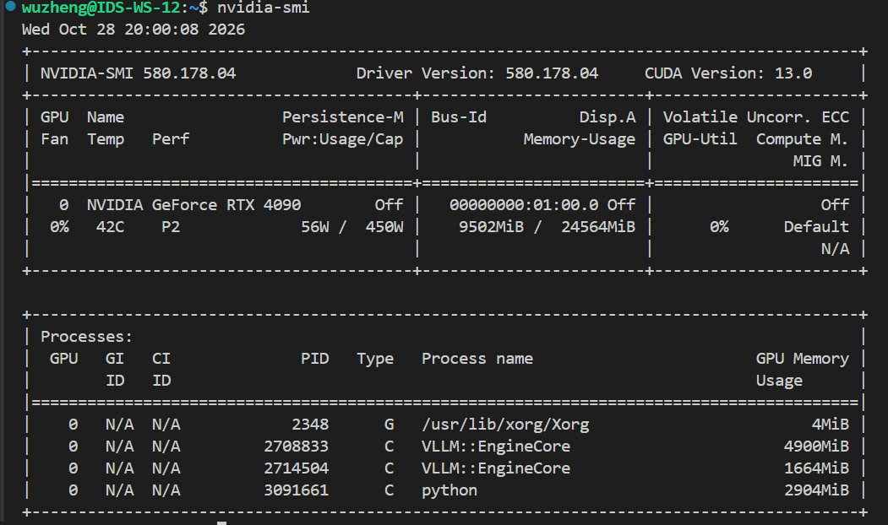
Figure 1. Local NVIDIA GeForce RTX 4090 GPU identification.
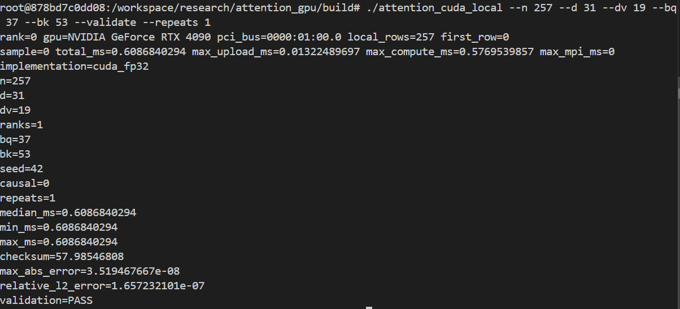
Figure 2. Local RTX 4090 full-attention validation at$N=257$.
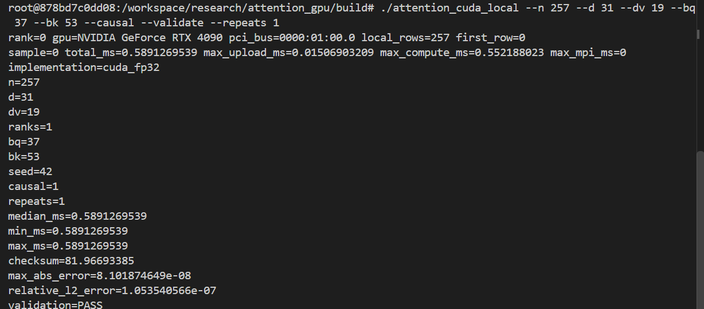
Figure 3. Local RTX 4090 causal-attention validation at $N=257$.
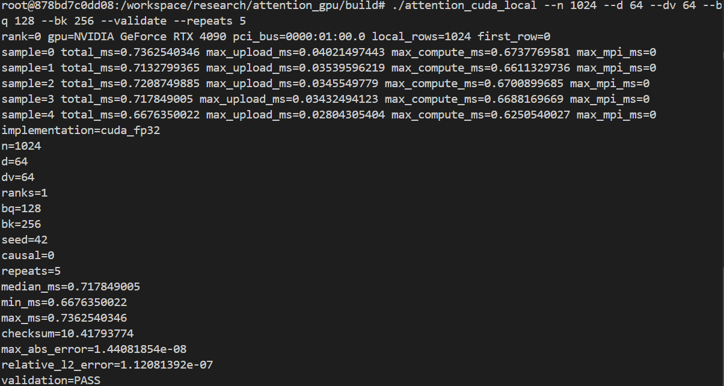
Figure 4. Local RTX 4090 full-attention benchmark at $N=1024$.
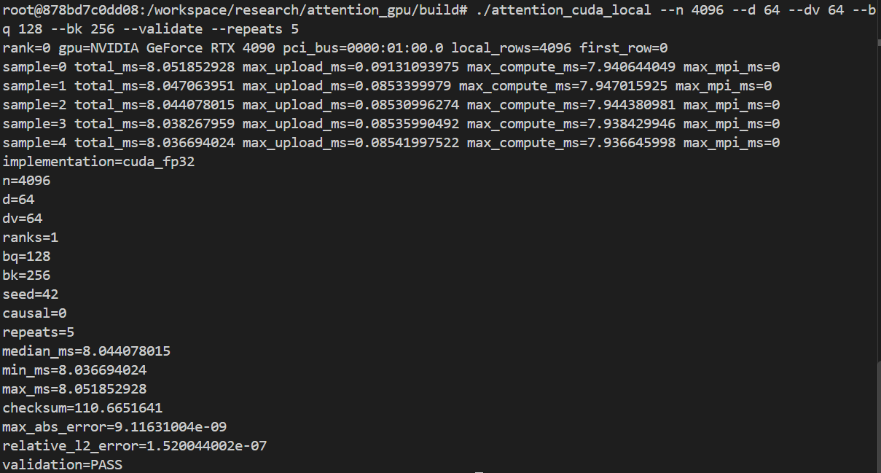
Figure 5. Local RTX 4090 full-attention benchmark at $N=4096$.

Appendix 2 Execution Log
Actual program source code is published separately from the execution commands: CUDA/MPI source: https://github.com/anaerovane/ProgressReport/tree/main/code/local_cuda ; Vanda serial CPU, OpenMP, and MPI+OpenMP source: https://github.com/anaerovane/ProgressReport/tree/main/code/vanda_cpu .
1. # JOB 1470561 | scripts/vanda_serial_free.pbs
2. #!/bin/bash
3. #PBS -q auto_free
4. #PBS -N attention_serial_cpu
5. #PBS -j oe
6. #PBS -l select=1:ncpus=1:mpiprocs=1:mem=4gb
7. #PBS -l walltime=00:30:00
8. set -euo pipefail
9. cd "$PBS_O_WORKDIR"
10. mkdir -p bin results
11. module load gcc/13.1.0
12. g++ -O3 -std=c++11 src/attention_serial.cpp -o bin/attention_serial
13. bin/attention_serial --n 257 --d 31 --dv 19 --repeats 5 --check > results/serial_cpu_257.txt
14. for n in 512 1024 2048 4096; do
15. bin/attention_serial --n "$n" --d 64 --dv 64 --repeats 5 > "results/serial_cpu_${n}.txt"
16. done
17. bin/attention_serial --n 2048 --d 64 --dv 64 --causal --repeats 5 > results/serial_cpu_2048_causal.txt
18. echo "serial_cpu_benchmarks=PASS"
19. # JOB 1470659 | scripts/vanda_openmp_free.pbs
20. #!/bin/bash
21. #PBS -q auto_free
22. #PBS -N attention_openmp_opt
23. #PBS -j oe
24. #PBS -l select=1:ncpus=8:mpiprocs=1:ompthreads=8:mem=16gb
25. #PBS -l walltime=00:30:00
26. set -euo pipefail
27. cd "$PBS_O_WORKDIR"
28. mkdir -p bin results/openmp_opt
29. module load gcc/13.1.0
30. g++ -O3 -std=c++17 -fopenmp src/attention_openmp.cpp -o bin/attention_openmp_opt
31. OMP_PLACES=cores OMP_PROC_BIND=close bin/attention_openmp_opt --n 257 --d 31 --dv 19 --threads 8 --repeats 3 --check > results/openmp_opt/openmp_257_t8.txt
32. for n in 1024 2048 4096 8192; do
33. for t in 1 2 4 8; do
34. OMP_PLACES=cores OMP_PROC_BIND=close bin/attention_openmp_opt --n "$n" --d 64 --dv 64 --threads "$t" --repeats 5 > "results/openmp_opt/openmp_${n}_t${t}.txt"
35. done
36. done
37. echo "openmp_cpu_benchmarks=PASS"
38. # LOCAL NVIDIA RTX 4090 | one-GPU CUDA validation
39. /tmp/attention_cuda_env/bin/nvcc -O2 -std=c++17 -arch=sm_89 \
40. -I/tmp/attention_cuda_env/include \
41. -I/opt/conda/lib/python3.11/site-packages/nvidia/cublas/include \
42. /tmp/attention_local/src/attention_cuda.cu \
43. -L/tmp/attention_cuda_env/lib -lcublas \
44. -o /tmp/attention_local/bin/attention_cuda
45. LD_LIBRARY_PATH=/tmp/attention_cuda_env/lib:/opt/conda/lib/python3.11/site-packages/nvidia/cublas/lib:/opt/conda/lib/python3.11/site-packages/nvidia/cuda_runtime/lib:${LD_LIBRARY_PATH:-} \
46. /tmp/attention_local/bin/attention_cuda \
47. --n 257 --d 31 --dv 19 --bq 37 --bk 53 --validate --repeats 1
48. # JOB 1475534 | initial placement check | no attention kernel was launched
49. MPI=(mpirun --prefix "$MPI_HOME" --hostfile "$HOSTFILE" -x PATH -x LD_LIBRARY_PATH -np 2)
50. HOST_OUTPUT="$("${MPI[@]}" hostname)"
51. mapfile -t LAUNCHED_HOSTS < <(printf '%s\n' "$HOST_OUTPUT" | sort -u)
52. printf 'MPI rank hosts: %s\n' "${LAUNCHED_HOSTS[*]}"
53. if [[ "${#LAUNCHED_HOSTS[@]}" -ne 2 ]]; then
54. echo "ERROR: expected two MPI ranks on two distinct nodes"
55. exit 22
56. fi

57. # JOB 1476015 | scripts/vanda_attention_multinode_smoke_free.pbs
58. #!/bin/bash
59. #PBS -q auto_free
60. #PBS -N attention_2node_smoke
61. #PBS -j oe
62. #PBS -l select=2:ncpus=4:mpiprocs=1:ngpus=1:node_pool=gpu_free:mem=16GB
63. #PBS -l place=scatter
64. #PBS -l walltime=00:10:00
65. set -euo pipefail
66. cd "$PBS_O_WORKDIR"
67. module load gcc/13.1.0
68. module load cuda12.4/toolkit/12.4.1
69. module load openmpi/gcc/64/4.1.8
70. MPI_BIN="$(readlink -f "$(command -v mpirun)")"
71. MPI_HOME="${MPI_HOME:-$(dirname "$(dirname "$MPI_BIN")")}"
72. export MPI_HOME PATH="$MPI_HOME/bin:$PATH"
73. export LD_LIBRARY_PATH="$MPI_HOME/lib:$MPI_HOME/lib64:${LD_LIBRARY_PATH:-}"
74. export OMPI_MCA_plm_rsh_agent=ssh
75. OUT=results/multinode_smoke_free
76. mkdir -p "$OUT" bin
77. HOSTFILE="$OUT/mpi_hosts"
78. sort -u "$PBS_NODEFILE" > "$HOSTFILE"
79. [[ "$(wc -l < "$HOSTFILE")" -eq 2 ]]
80. nvcc -O3 -std=c++17 -arch=sm_86 -ccbin mpicxx -DATTENTION_MPI=1 -DOMPI_SKIP_MPICXX=1 src/attention_cuda.cu -lcublas -o bin/attention_mpi_cuda
81. MPI=(mpirun --prefix "$MPI_HOME" --hostfile "$HOSTFILE" --map-by ppr:1:node --rank-by node -x PATH -x LD_LIBRARY_PATH -np 2)
82. HOST_OUTPUT="$("${MPI[@]}" hostname)"
83. mapfile -t RANK_HOSTS < <(printf '%s\n' "$HOST_OUTPUT" | sort -u)
84. [[ "${#RANK_HOSTS[@]}" -eq 2 ]]
85. "${MPI[@]}" bin/attention_mpi_cuda --n 257 --d 31 --dv 19 --bq 37 --bk 53 --validate --repeats 1
86. echo "MULTINODE_SMOKE=PASS"
87. # JOB 1476284 | scripts/vanda_attention_multinode_all_free.pbs
88. #!/bin/bash
89. #PBS -q auto_free
90. #PBS -N attention_2node_all
91. #PBS -j oe
92. #PBS -l select=2:ncpus=4:mpiprocs=1:ngpus=1:node_pool=gpu_free:mem=16GB
93. #PBS -l place=scatter
94. #PBS -l walltime=01:00:00
95. set -euo pipefail
96. cd "$PBS_O_WORKDIR"
97. mkdir -p bin results/multinode_all
98. module load gcc/13.1.0
99. module load cuda12.4/toolkit/12.4.1
100. module load openmpi/gcc/64/4.1.8
101. MPI_BIN="$(readlink -f "$(command -v mpirun)")"
102. MPI_HOME="${MPI_HOME:-$(dirname "$(dirname "$MPI_BIN")")}"
103. export MPI_HOME PATH="$MPI_HOME/bin:$PATH"
104. export LD_LIBRARY_PATH="$MPI_HOME/lib:$MPI_HOME/lib64:${LD_LIBRARY_PATH:-}"
105. export OMPI_MCA_plm_rsh_agent=ssh
106. OUT=results/multinode_all
107. HOSTFILE="$OUT/mpi_hosts"
108. sort -u "$PBS_NODEFILE" > "$HOSTFILE"
109. [[ "$(wc -l < "$HOSTFILE")" -eq 2 ]]
110. g++ -O3 -std=c++11 src/attention_serial.cpp -o bin/attention_serial
111. nvcc -O3 -std=c++17 -arch=sm_86 src/attention_cuda.cu -lcublas -o bin/attention_cuda
112. nvcc -O3 -std=c++17 -arch=sm_86 -ccbin mpicxx -DATTENTION_MPI=1 -DOMPI_SKIP_MPICXX=1 src/attention_cuda.cu -lcublas -o bin/attention_mpi_cuda
113. MPI=(mpirun --prefix "$MPI_HOME" --hostfile "$HOSTFILE" --map-by ppr:1:node --rank-by node -x PATH -x LD_LIBRARY_PATH -np 2)
114. HOST_OUTPUT="$("${MPI[@]}" hostname)"
115. mapfile -t LAUNCHED_HOSTS < <(printf '%s\n' "$HOST_OUTPUT" | sort -u)
116. [[ "${#LAUNCHED_HOSTS[@]}" -eq 2 ]]
117. "${MPI[@]}" bin/attention_mpi_cuda --n 257 --d 31 --dv 19 --bq 37 --bk 53 --validate --repeats 3 --output "$OUT/ring_257.csv"
118. "${MPI[@]}" bin/attention_mpi_cuda --n 257 --d 31 --dv 19 --bq 37 --bk 53 --causal --validate --repeats 3 --output "$OUT/ring_causal_257.csv"
119. for n in 1024 2048 4096 8192; do
120. "${MPI[@]}" bin/attention_mpi_cuda --n "$n" --d 64 --dv 64 --bq 128 --bk 256 --repeats 5
121. done
122. for n in 2048 4096; do
123. for bq_bk in "64 128" "64 256" "128 128" "128 256"; do
124. read -r bq bk <<< "$bq_bk"
125. "${MPI[@]}" bin/attention_mpi_cuda --n "$n" --d 64 --dv 64 --bq "$bq" --bk "$bk" --repeats 3
126. done
127. done
128. for n in 4096 8192; do
129. for mask in full causal; do
130. args=()
131. if [[ "$mask" == causal ]]; then args+=(--causal); fi
132. "${MPI[@]}" bin/attention_mpi_cuda --n "$n" --d 64 --dv 64 --bq 128 --bk 256 --repeats 5 "${args[@]}"
133. done
134. done
135. for pair in "512 724" "1024 1448" "2048 2896" "4096 5793"; do
136. read -r n1 n2 <<< "$pair"
137. bin/attention_cuda --n "$n1" --d 64 --dv 64 --bq 128 --bk 256 --repeats 5
138. "${MPI[@]}" bin/attention_mpi_cuda --n "$n2" --d 64 --dv 64 --bq 128 --bk 256 --repeats 5
139. done
140. echo "MULTINODE_FULL_EXPERIMENTS=PASS"

141. # JOB 1476448 | scripts/vanda_attention_multinode_all_batch.pbs
142. #!/bin/bash
143. #PBS -P personal-dongwuzheng
144. #PBS -q auto
145. #PBS -N attention_2node_batch
146. #PBS -j oe
147. #PBS -l select=2:ncpus=4:mpiprocs=1:ngpus=1:mem=16GB
148. #PBS -l place=scatter
149. #PBS -l walltime=01:00:00
150. set -euo pipefail
151. cd "$PBS_O_WORKDIR"
152. mkdir -p bin results/multinode_all
153. module load gcc/13.1.0
154. module load cuda12.4/toolkit/12.4.1
155. module load openmpi/gcc/64/4.1.8
156. MPI_BIN="$(readlink -f "$(command -v mpirun)")"
157. MPI_HOME="${MPI_HOME:-$(dirname "$(dirname "$MPI_BIN")")}"
158. export MPI_HOME PATH="$MPI_HOME/bin:$PATH"
159. export LD_LIBRARY_PATH="$MPI_HOME/lib:$MPI_HOME/lib64:${LD_LIBRARY_PATH:-}"
160. export OMPI_MCA_plm_rsh_agent=ssh
161. OUT=results/multinode_all
162. HOSTFILE="$OUT/mpi_hosts"
163. sort -u "$PBS_NODEFILE" > "$HOSTFILE"
164. [[ "$(wc -l < "$HOSTFILE")" -eq 2 ]]
165. g++ -O3 -std=c++11 src/attention_serial.cpp -o bin/attention_serial
166. nvcc -O3 -std=c++17 -arch=sm_86 src/attention_cuda.cu -lcublas -o bin/attention_cuda
167. nvcc -O3 -std=c++17 -arch=sm_86 -ccbin mpicxx -DATTENTION_MPI=1 -DOMPI_SKIP_MPICXX=1 src/attention_cuda.cu -lcublas -o bin/attention_mpi_cuda
168. MPI=(mpirun --prefix "$MPI_HOME" --hostfile "$HOSTFILE" --map-by ppr:1:node --rank-by node -x PATH -x LD_LIBRARY_PATH -np 2)
169. HOST_OUTPUT="$("${MPI[@]}" hostname)"
170. mapfile -t LAUNCHED_HOSTS < <(printf '%s\n' "$HOST_OUTPUT" | sort -u)
171. [[ "${#LAUNCHED_HOSTS[@]}" -eq 2 ]]
172. "${MPI[@]}" bin/attention_mpi_cuda --n 257 --d 31 --dv 19 --bq 37 --bk 53 --validate --repeats 3 --output "$OUT/ring_257.csv"
173. "${MPI[@]}" bin/attention_mpi_cuda --n 257 --d 31 --dv 19 --bq 37 --bk 53 --causal --validate --repeats 3 --output "$OUT/ring_causal_257.csv"
174. for n in 1024 2048 4096 8192; do
175. "${MPI[@]}" bin/attention_mpi_cuda --n "$n" --d 64 --dv 64 --bq 128 --bk 256 --repeats 5
176. done
177. for n in 2048 4096; do
178. for bq_bk in "64 128" "64 256" "128 128" "128 256"; do
179. read -r bq bk <<< "$bq_bk"
180. "${MPI[@]}" bin/attention_mpi_cuda --n "$n" --d 64 --dv 64 --bq "$bq" --bk "$bk" --repeats 3
181. done
182. done
183. for n in 4096 8192; do
184. for mask in full causal; do
185. args=()
186. if [[ "$mask" == causal ]]; then args+=(--causal); fi
187. "${MPI[@]}" bin/attention_mpi_cuda --n "$n" --d 64 --dv 64 --bq 128 --bk 256 --repeats 5 "${args[@]}"
188. done
189. done
190. for pair in "512 724" "1024 1448" "2048 2896" "4096 5793"; do
191. read -r n1 n2 <<< "$pair"
192. bin/attention_cuda --n "$n1" --d 64 --dv 64 --bq 128 --bk 256 --repeats 5
193. "${MPI[@]}" bin/attention_mpi_cuda --n "$n2" --d 64 --dv 64 --bq 128 --bk 256 --repeats 5
194. done
195. echo "MULTINODE_FULL_EXPERIMENTS=PASS"
196. # JOB 1475539 | scripts/vanda_attention_single_node_check_free.pbs
197. #!/bin/bash
198. #PBS -q auto_free
199. #PBS -N attention_1node_check
200. #PBS -j oe
201. #PBS -l select=1:ncpus=8:mpiprocs=2:ngpus=2:mem=16GB:node_pool=gpu_free
202. #PBS -l place=pack
203. #PBS -l walltime=00:10:00
204. set -euo pipefail
205. cd "$PBS_O_WORKDIR"
206. mkdir -p bin results/multinode_all
207. module load gcc/13.1.0
208. module load cuda12.4/toolkit/12.4.1
209. module load openmpi/gcc/64/4.1.8
210. MPI_BIN="$(readlink -f "$(command -v mpirun)")"
211. MPI_HOME="$(dirname "$(dirname "$MPI_BIN")")"
212. export PATH="$MPI_HOME/bin:$PATH"
213. export LD_LIBRARY_PATH="$MPI_HOME/lib:$MPI_HOME/lib64:${LD_LIBRARY_PATH:-}"
214. nvcc -O2 -std=c++17 -arch=sm_86 -ccbin mpicxx -DATTENTION_MPI=1 -DOMPI_SKIP_MPICXX=1 src/attention_cuda.cu -lcublas -o bin/attention_mpi_cuda_single_node_check
215. mpirun --prefix "$MPI_HOME" -np 2 --map-by ppr:2:node -x PATH -x LD_LIBRARY_PATH bin/attention_mpi_cuda_single_node_check --n 257 --d 31 --dv 19 --bq 37 --bk 53 --validate --repeats 1 --output "results/multinode_all/single_node_check_${PBS_JOBID}.csv"
216.

